horizontal line

**Zombieland CLI Team**

Cali, Colombia

MVP specification

# Automatic Translations, Skillshare.

**May 20, 2020**

##### **Team**

1. Carlos Andres Garcia (agzsoftsi)
2. Ivan Dario Lasso (ilasso)
3. Leonardo Calderon (leocjj)

# Architecture

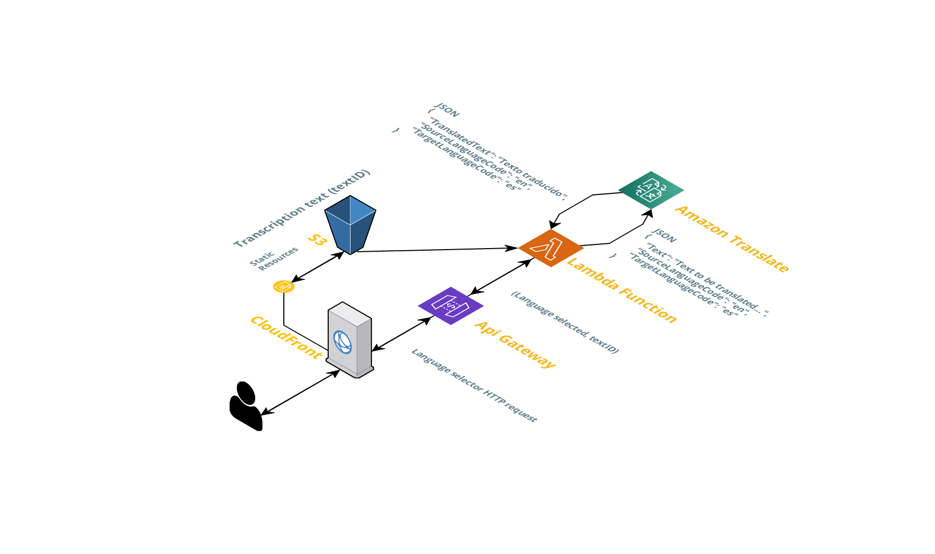

# APIs and Methods

Create an API service that can take in three parameters

(TargetLanguageCode, SourceLanguageCode, TextSource).

From these three parameters, the API service should take the TextSource and then pass it through to AWS translate. Based on TargetLanguageCode and SourceLanguageCode, AWS translate will respond with the translated transcript.

Future considerations include _how_ the API service will be triggered. For example; via an API Gateway, directly from an upload event, or other events.

It returns:

{ “TranslateText”, “SourceLanguageCode”, “TargetLanguageCode”}

This api gateway invokes an aws lambda service that invokes amazon translate service.

# Data Modelling

In this scope, no data model is required since the aws translate service does the translation in real time and it is returned by the api service.

For this architecture no data persistence is required, we only represent the data from JSONs for the consumption of a resource (transcription) from S3, which would be the only data stored, and these accessed through the API

# User Stories

Internationalization has been a big part of our goals for this year, and we want to get closer to that objective by allowing users to see the video transcripts in their native language.

We already support transcript in English for all our Original classes, we are looking to implement a solution that would allow users to auto-translate these transcripts into the language of their choosing.

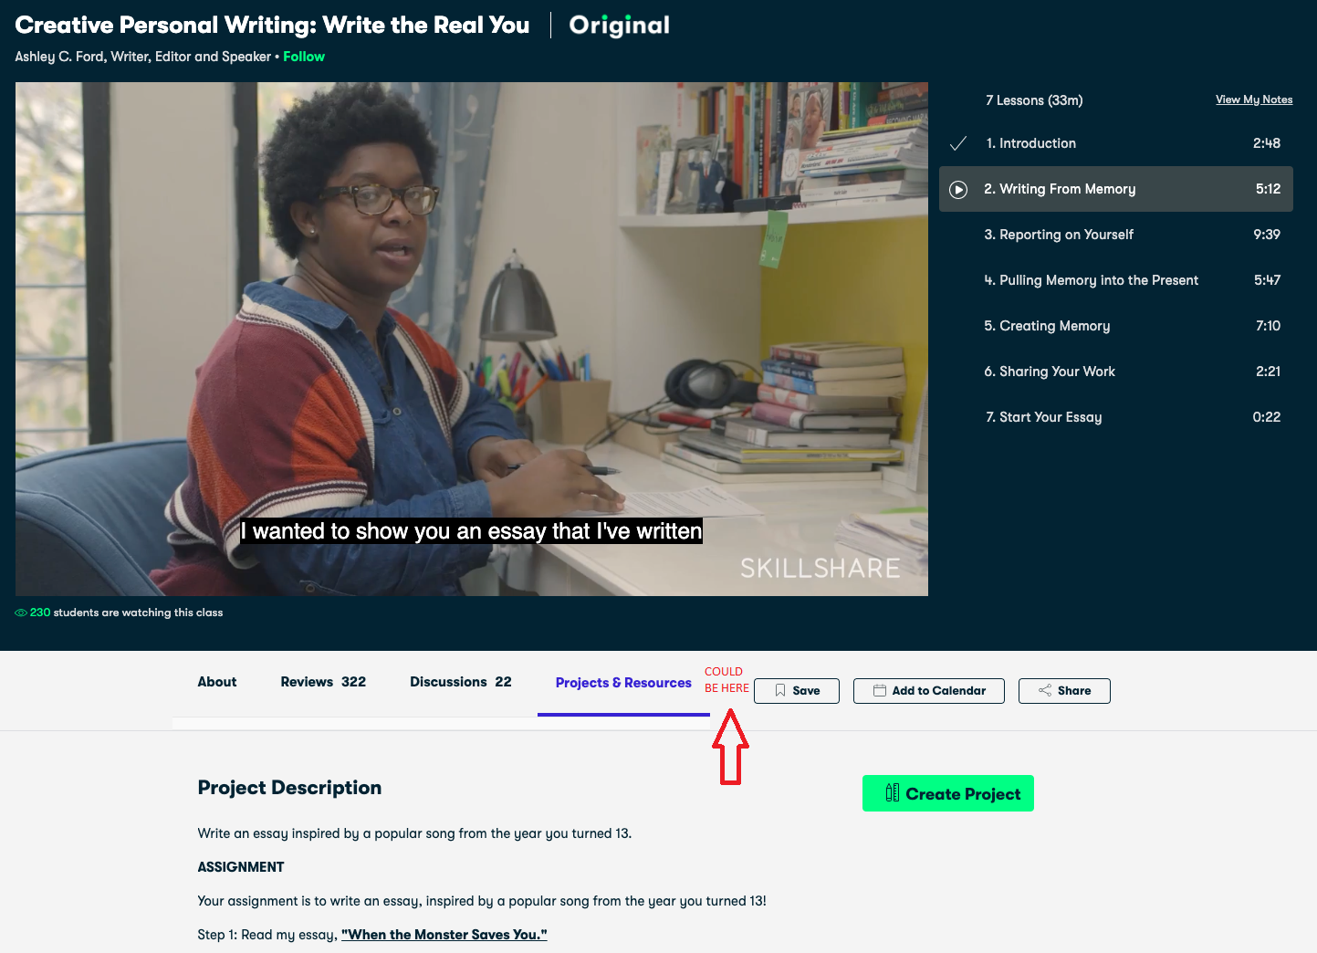

**User one:** “I want to have the option to select my own language and read transcriptions easily in my video page while I’m seeing the video”.

**User two:** “What if when I’m reading transcription in my own language, I click on a phrase and the video goes to that part exactly”

**User three:** “I want all this because it will be more useful for me to see transcriptions of the video in my language. I think this is a must for foreing users.”

We want to allow users to choose a language for transcripts. They can also click a certain part of the transcripts and the video player will jump to the specific part of the video that plays the text they clicked on.

For the scope of this task, we are focusing only on transcripts, but if time permits, we would also like to evaluate solutions for multilingual subtitles.

One possible option on where we would like to see the translated transcripts is in the class menu, it may be a menu item that comes after "Projects and Resources" (check the red arrow), which would show an option to choose a language for transcripts. But, since it's a backend rather than a frontend task, location isn't as important as implementation details.

# Mockups

The new feature can display the transcription translated in other languages with the time of each track. similar to the following picture:

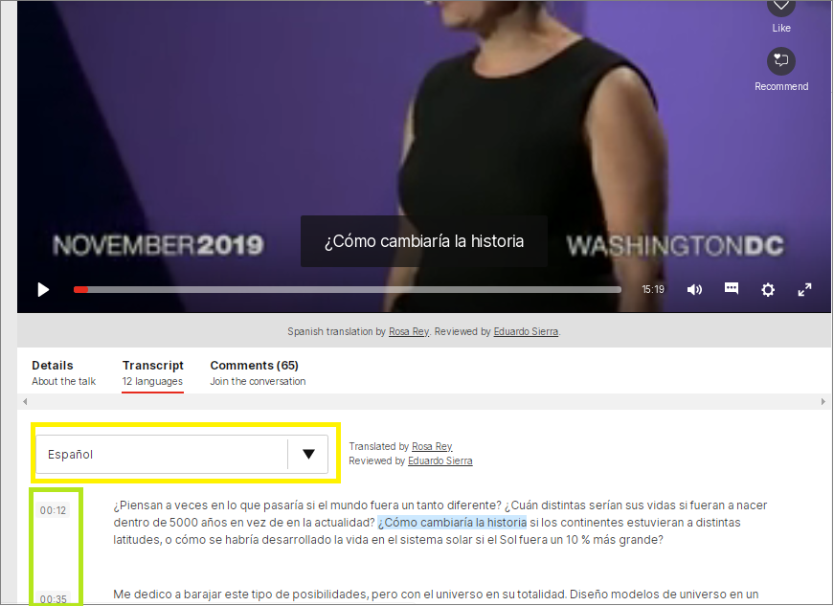

The audio originates from this video is in the English language, which was transcribed for subtitles (out of the scope of the project). These subtitles in turn are translated, in this case into the Spanish language.

Take a close look at the text highlighted in light blue “**¿Cómo cambiaría la historia**”. This corresponds to the subtitle that is displayed at this time in the video and in turn corresponds to a period of time in which the speaker is saying that phrase.

The language in which the translation is being made is indicated in the box marked in yellow.

The green box indicates the time in the video where the paragraph begins.

**Specific steps to do in frontend**

To add “Transcription” menu item:

1. To show transcriptions in full text. // To get from S3 in AWS.
2. To show language selector // English, Spanish.
   1. Add selector event → to send HTTP request to AWS API Gatway

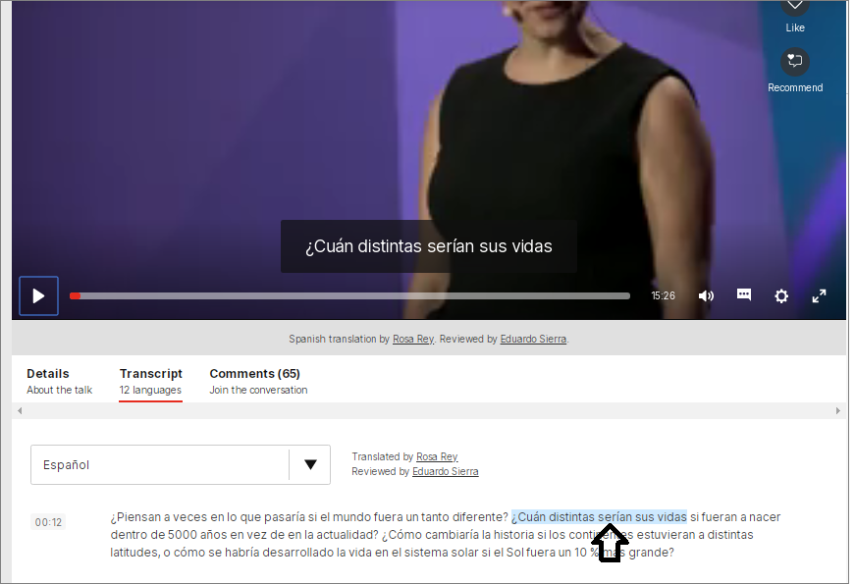

If the user clicks any part of the text as shown in the previous image, the video will automatically be located in that place within the video track displaying the beginning of the phrase.

And finally the user can change language:

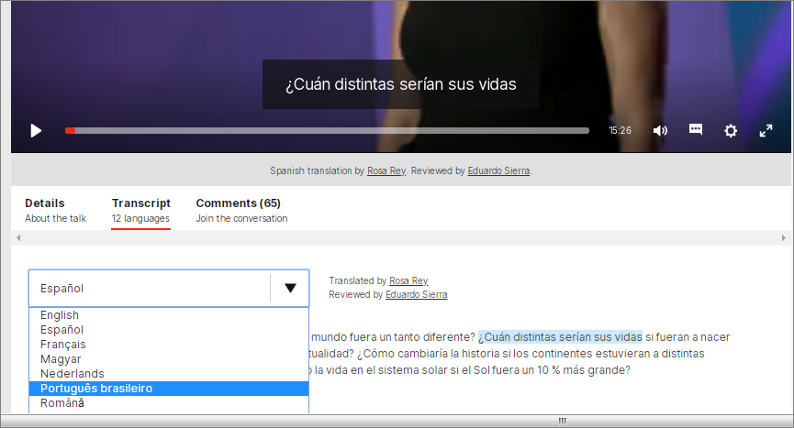

As can be seen, the subtitles are translated into the selected language.

In this scope:

* The translations were only displayed at the bottom and not within the video.
* The transcribed and translated text will only be displayed but it will not have the functionality to mark a phrase and that the video will automatically locate the exact place.
* There will only be translations from two languages.
* Translations will not be subtitled within the video.
* This scope does not include any additional consideration for handling more than one speaker.